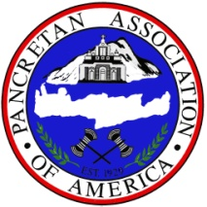

PAA MENTOR PROGRAM FAQ’S

What is the PAA Mentor Program?
The goal of the Mentor Program is offer a leadership experience for mentors to connect with, support and encourage aspiring young adults working towards their future in the professional world. Through our on-line process, we are connecting mentees, or future leaders to an experienced professional or mentor somewhere in the US or Canada.

How do I sign up to be a mentor?
You can sign up right through our website at www.paamentorprogram.weebly.com . Your submission will be directly forwarded to our program coordinator.

How do I connect with a mentor?
You can contact the person you are interested in connecting with directly at their e-mail address on our website.

When contacting a mentor, you will need to set up a time to conduct a professional phone call discussion or e-mail exchange. Here you will have the opportunity to seeking the advice of the mentor.

After connecting with a mentor, it is appropriate to send a thank you note for their time. Mentors are volunteering their time to those seeking their advice and expertise.

What are the goals of the program?
We hope this opportunity encourages leadership, guidance from within our organization, and strengthens the capacity of our youth to excel, innovate, collaborate, and serve as effective leaders in their communities. The goal of the Mentor Program is to also build meaningful connections across the United States and Canada across generations and increase opportunities for our youth to connect with successful role models of our organization.

Who do I contact if I have any more questions?
You may contact the Mentor Program Coordinator at mentorprogram@pancretan.org

